# Project 2 – Tournament Bracket Web App

## Advanced Web Programming – Tom Tsiliopoulos

### Dylan Scott – James McColl



**Table of Contents**

1. Detailed Description
2. Website Wireframes
3. Screen Capture
4. Future Functionality

# Detailed Description –

This website was designed to give users a place where they can record their prediction for the outcomes of their favorite teams in whatever sport they wish. The website takes a list of players from the user and then generates a form that users can pick the desired winner for each bracket. The form then re-generates with the new brackets until the user picks the final winner. Once a winner is picked the webpage announces the winner. The user also has the ability to manage his account and log out.

# Website Wireframes

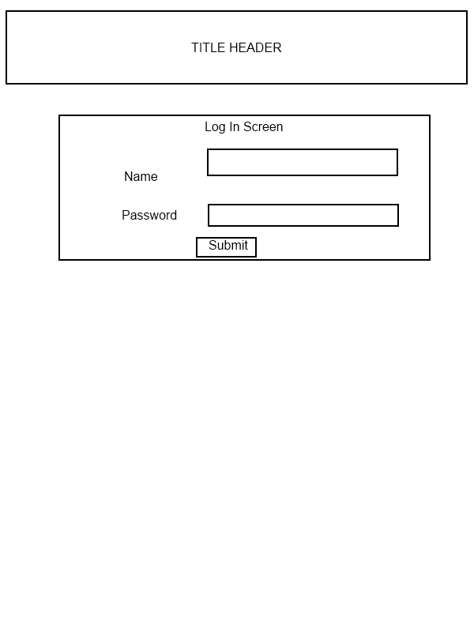

# 

# 

# Screen Captures –

## Index-

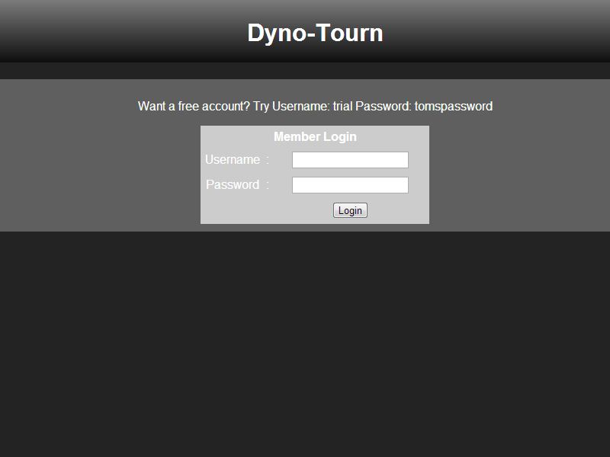

## Create a tournament –

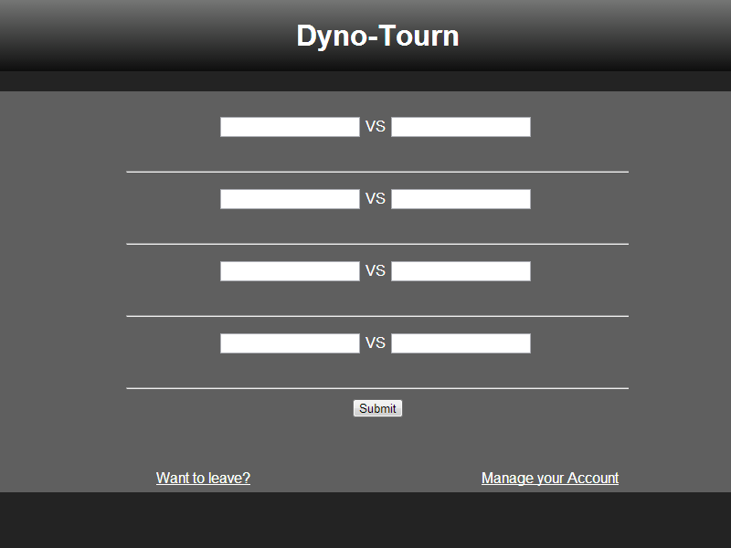

## Pick Round winners-C:\Users\Dylan\Pictures\project2\round.png

## Manage User –

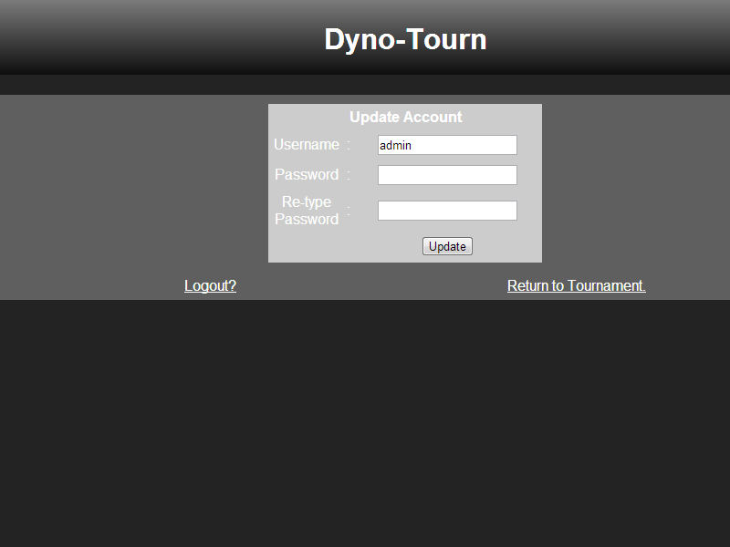

## Potential Future Functionality –

For future development we would like to better re-create the tournament brackets to allow users to get a real visual showing of the tournament brackets. We would like to add the ability for users to go back and change their current active tournaments to adjust a players standing.